Economic analysis of alternative energy development in Nagorno-Karabakh and surrounding regions

Aida Guliyeva^{1*}, Parvin Mammadzada^{1,2}, Turan Mamedov³

1“SABAH” center, Azerbaijan State University of Economics, UNEC, Istiqlaliyyat str. 6, Baku, Azerbaijan.
2Department of World Electric Power Industry, International Institute of Energy Policy and Diplomacy at Moscow State University of International Relations (MGIMO University) under MFA, 76 Prospekt Vernadskogo, Moscow, Russian Federation
3Department of Economics of Oil and Gas Industry, State University of Oil and Gas "Gubkin University" (Gubkin University), 65 Leninsky Prospekt, Moscow, Russian Federation

Abstract. This paper studies the main opportunities for stimulating investments in the alternative energy development through implementation of state plans for creation and support of favourable socio-economic conditions in Nagorno-Karabakh and 7 surrounding regions. Due to the longevity of projects on renewable energy sources, as well as the traditional financing of infrastructure projects, it is extremely important that political and economic interests were protected by law. At the present time there are active project work on development and optimisation of energy sector, and therefore understanding of basic principles is quite diverse in public and private sectors. Main conclusions and recommendations are developed and presented for economic development of renewable energy sources (RES) in Nagorno-Karabakh and surrounding regions of Azerbaijan.

Introduction

The ever-increasing demand for energy, limited hydrocarbons and environmental challenges via traditional energy production have enforced the need of RES use. The declining level of provision of the global economy with gas and oil reserves has marked the trend of a new energy reality. In these conditions, the interest of industrially developing consumers in renewable energy sources (RES) has been formed, that is, solving the energy problem in the face of an ever-increasing demand for energy resources has become an agenda and an urgent message in the scientific world.
In order to support RES development, the government approved the "State Program on the Use of Alternative and Renewable Energy Sources in the Republic of Azerbaijan" by Decree No. 462 dated October 21, 2004, for stimulating RES development and preparation of short-, medium- and long-term strategic action plans [1]. In April 2016, official Azerbaijan approved the Paris Agreement on Climate Change, in which RES implementation and CO2

* Corresponding author: guliyevaaida@ymail.com

© The Authors, published by EDP Sciences. This is an open access article distributed under the terms of the Creative Commons Attribution License 4.0 (http://creativecommons.org/licenses/by/4.0/).

reduction were identified as priority areas of activity [2]. Renewable energy targets include increasing their share by 2020 to 20% in electricity generation and to 9.7% in total energy consumption and reducing losses in gas distribution systems [3]. At the same time, it is planned to commission power plants based on renewable energy sources with a total capacity of 2 thousand MW. By 2030, the target is to reduce carbon dioxide emissions by 35% compared to the 1990 baseline [2,3]. At present, RES covers 16.8% of total electricity production [2,4]. In 2017, alternative energy covered 2.0 billion kWh of electricity and 3789.2 Gcal of thermal energy, which saved 504.5 million cubic meters of natural gas in the same year and prevented the emission of 898.0 thousand tons of carbon dioxide. gas (CO2) into the atmosphere [4].
According to forecasts, by 2030 RES will provide 35-50% of global electricity production and 19-25% of total energy consumption. Renewables will face a bigger challenge in penetrating the automotive fuel market, providing only 7% of the world's fuel [5]. The growth rates of consumption of primary energy resources will decrease to 1.6% per year by 2030; energy consumption per capita will grow by 0.7% per year [6].
The aim of the paper is to cover theoretical basis for realizing methodological and practical recommendations for RES implementation due to expansion of international economic cooperation in the electric power industry of Azerbaijan. To achieve this goal the following tasks were set:
- Determine the criteria, methods of macroeconomic factors of international cooperation;
- Analyze the modernization and innovative development of the Azerbaijani economy;
- Determine the ratio of reducing dependence on petroleum and increasing role of RES in energy;
- Formulate practical recommendations for creating a regional model of the electric power transmission system.

Materials and methods

The nature of research is mixed, using exploratory and inductive types of research. Subsequently, a qualitative methodology was used to gain insight into alternative energy and design techniques. The following structure is proposed for the methodology: at the first stage, various scientific articles were used to determine the structure and scheme for the introduction and use of alternative energy. At the second stage, information obtained through data collection through interviews, observations and studies of advanced countries in the field of alternative energy was used. The methodological basis of the paper will be:

- local and international regulations of RES implementation;
- the provisions of the doctrine of environmental and energy law;
- a set of theoretical and practical methods for solving macroeconomic problems associated with the transition to innovative development;
- methods and tools for stimulating renewable energy projects.

Considering global electricity issues in the work, the information and empirical base was compiled by the annual reports of the SAARES, IRENA, IEA, World Bank, MoE of Azerbaijan, UN, REN21, UNCTAD, as well as the Electricity Directive of EP, Regulation on Access to Electricity Networks and legislative acts of Azerbaijan.
Azerbaijan, an exporter of net energy, meets energy demands through the domestic extraction of hydrocarbon resources, specifically natural gas and oil. Also shared with neighbor countries (Russia, Kazakhstan, Turkmenistan, and Iran), Caspian Sea reservoirs

proved oil resources were estimated at 7 billion barrels in 2018, comparable to the North Sea's capacity decades ago [7].
Table 1 reveals that Azerbaijan’s internal energy consumption is five times less than its export. Consolidation of the reduced wood utilization as a raw material for energy, with the volatile nature of hydropower production, had led to a decline in primary renewable energy production. Individually, the reduction in wood use is attributed to the installation of vapor heaters and the advancement of the region heating system [8].

Table 1. Energy balance in selected years, 2010–2017

Indicators  (Tonne of oil equivalent) | 2010 | 2014 | 2015 | 2016 | 2017
Primary products, including: | 68 254.6 | 61 132.0 | 61 084.2 | 59 977.6 | 57 036.0
Raw oil | 52 312.5 | 43 295.9 | 42 835.5 | 42 240.9 | 39 810.4
Natural gas | 15 555.6 | 17 565.1 | 17 947.3 | 17 463.5 | 16 967.6
Renewable energy and wastes | 386.5 | 271.0 | 301.4 | 273.5 | 258.0
Net imports of energy products | - 54 300.2 | - 45 869.5 | - 45 747.4 | - 44 693.0 | - 40 789.6
General power supply | 12 566.5 | 15 085.5 | 15 569.4 | 15 393.5 | 15 471.9
Transformation processes | -2 692.7 | -3 491.3 | -3 819.7 | -3 731.0 | -4 020.6
Energy for own consumption | 931.1 | 1 188.2 | 1 167.0 | 1 133.0 | 1 147.7
Total final energy consumption | 6 710.6 | 8 241.7 | 8 304.3 | 8 644.9 | 8 210.0

According to the Ministry of Ecology and Natural Resources of Azerbaijan (MENR), environmental safety is of paramount importance, the policy is primarily aimed at reducing human influence on the nature and coordinating environmental protection. Taking into account the demands, the other policy direction is the efficient use of natural resources, including RES implementation. Assessing the country's needs in global environmental problems, developing solutions for them and making decisions through cooperation with international organizations is the third aspect of Azerbaijan's environmental policy [9].
The State Program on the Use of Alternative and Renewable Energy Sources in the Republic of Azerbaijan was approved by the Presidential Decree No. 462 of October 21, 2004 and became a new milestone in Azerbaijan's energy policy [1]. The goal of the State Program was to promote the generation of electricity from renewable and environmentally friendly sources and more efficient use of hydrocarbon energy sources.
Given that RES is a relatively new and unconventional sector in Azerbaijan, the country has nevertheless achieved significant success. First, these are legal problems for both the production and use of renewable energy sources. RES investments in Azerbaijan are mainly carried out by the government and international organizations, and the draft law is still under discussion. Secondly, these are technical problems, primarily related to technology transfer. Renewable energy technologies are expensive investments, and given that Azerbaijan imports them from other countries, it is necessary to simplify technical procedures. For a long time, the country's electricity has been dominated by oil and natural gas, which have a significantly established nature of technology and experience, which constitutes serious competition for renewable energy sources. The third problem is low awareness. There is a lack of support from international organizations and local authorities to raise public awareness of RES in Azerbaijan [10].
Azerbaijan is completely electrified, meaning the electrification level reaches 100%. The country's total installed capacity is over 7,141 MW, with 60% derived from thermal power (TPP), specifically, 15 thermal and 14 hydroelectric power plants. TPP is the largest power

plant in the country with capacity over 2,400 MW (oil-based) [4,9]. Also, factories are constructed, taking into account the requirements of industrial design for efficiency and reliability [4]. The latest TPPs are advanced and operate on the use of gas turbine steam cycle technologies [4]. Considering installed capacity of renewable sources, hydro energy is leading (1,134 MW), followed by wind (66 MW), biomass (38 MW) and solar PV (33 MW). Table 2 presents data on electricity generation by source in 2019 [4,9].

Table 2. Electricity production by RES source (GWh)

Energy source | 2010 | 2011 | 2012 | 2013 | 2014 | 2015 | 2016 | 2017
Thermal | 15 262.7 | 17 618.0 | 21 167.1 | 21 729.6 | 23 249.3 | 22 859.9 | 22 761.0 | 22 344.9
Hydro | 3 446.3 | 2 675.8 | 1 821.0 | 1 489.1 | 1 299.7 | 1 637.5 | 1 959.3 | 746.4
Wind | 0.5 | - | - | 0.8 | 2.3 | 4.6 | 22.8 | 22.1
Solar | - | - | - | 0.8 | 2,9 | 4.6 | 35.3 | 37.2
Biomass | - | - | - | 134.1 | 173.5 | 181.8 | 174.5 | 170.3
Total | 18 709.5 | 20 293.8 | 22 988.1 | 23 354.4 | 24 727.7 | 24 688.4 | 24 952.9 | 24 320.9

According to the Ministry of Energy, over 4,000 MV of solar and up to 500 MV of wind energy potentials and 25% of national hydro resources, or over 2.56 bln m3 of water per year formed in Nagorno-Karabakh and surrounding areas (Figures 1 and 2).

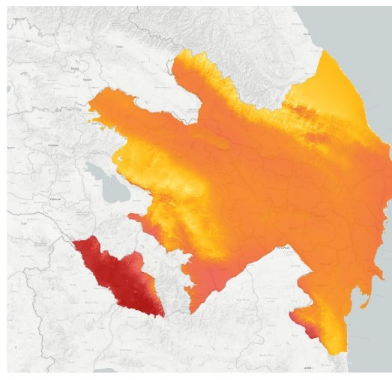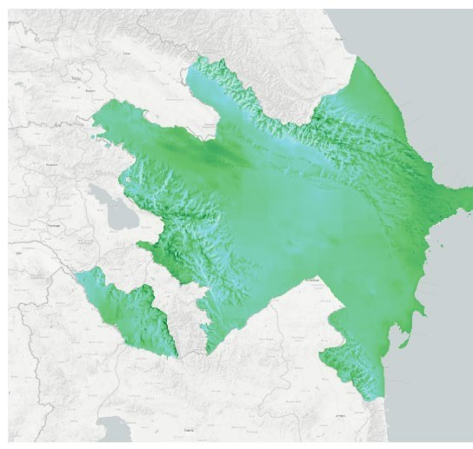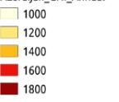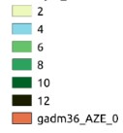
Fig. 1. Annual global horizontal solar emission (kWh/m2) Fig. 2. Wind speed at 100 meters
(m/s)

Improving secure energy supply, creating decentralized power grids, reducing the share of power outages and diversifying energy sources provide and accelerate access to energy for residents of Azerbaijan and remote areas in the liberated territories. In a country dominated by oil and gas, alternative energy will provide a catalyst for new job opportunities, technological innovation, and new opportunities for economic creation in Nagorno-Karabakh and surrounding regions [12].

Results and discussion

The main objectives of the development of alternative energy should be to reduce risk, stimulate deployment and reduce losses. The facts testify to the fact that a significant share

of breakthrough innovations comes from new firms that challenge existing business models. Thus, state actions to eliminate barriers to entry foreign companies have positive impact on stimulation of low-carbon energy technologies. Electricity markets in the European Union, as well as in other regions of the world, undergo significant transformations that lead to growth in terms of electricity safety. We are witnessing a rapid growth of renewable, often decentralized electricity generation, which is due to the goals and policies in the field of decarbonization and a sharp reduction in the cost of energy use. Meanwhile, there is reduction of traditional, centralized and more flexible generating capabilities. Another factor that affects the change in the landscape of electricity markets is the availability of innovative low- carbon solutions to balance the demand and supply. Figure 3 shows an illustration of possible changes in the landscape power system for the Azerbaijani power supply system based on renewable energy sources [13].
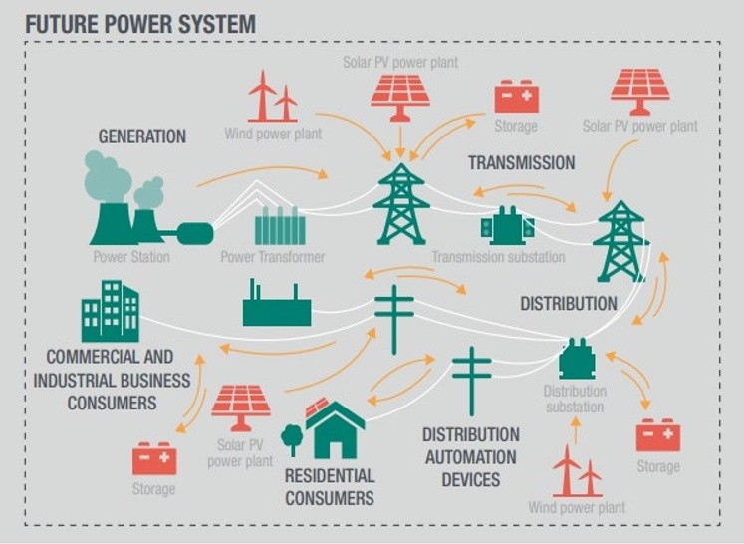
Fig. 3: Future low carbon decentralized power system

The basic principle of government as a market maker is to exert competitive pressure between buyers and sellers. The goal is to harness the power of the markets to achieve broader policy goals. Well-designed market processes can avoid the constraints of competition from more traditional command-and-control approaches. The market mechanism, in which the government plays a role in the design, control and application of the market, must provide the necessary incentives for the effective provision of goods or services while achieving the same policy objectives [14,15].

Conclusions

Azerbaijan has made colossal steps in the energy sector over the past decade; electricity generation's capacity surpasses 7,100 MW and expands by approximately 40%. The primary

reason for improving electricity generation capacity is close attention to combining an innovative generating capacity over 2.3 GW from 2006 to 2015. Azerbaijan actively partners with several countries, domestic and foreign organizations, and financial institutions in RES in-depth development [4,9].
The sustainability of Azerbaijan's power system additionally depends on the advancement of renewable energy sources. For instance, the country can improve the security of supply through enhanced utilization of batteries consolidated with distributed renewable power systems. In addition, renewable energies provide a technical solution for the rapid deployment of production capacity due to a relatively shorter predicted adaptation time than traditional sources, taking into account the projected growth in national energy needs.
Government issued Presidential Decree No. 1138, on Strategic Roadmap to improve utilities (electricity and heat, water and gas supplies), which consists strategic vision to 2020, long-term vision to 2025 and target vision to post-2025. Over the next 5-10 years, to increase generating capacity by 1000 MW, investments will be made in the supply of sufficient quantities electricity in addition to the planned investment [16].
Economic Energy Efficiency and Renewable Energy Initiatives that affect the demand for energy services tend to change the patterns of energy consumption by business and residential consumers by reducing the amount of energy required for a given level of production or service. Initiatives to increase demand for energy efficiency in the field of alternative energy led to direct costs and savings. Supply-side policies generally support RES development, hybrid heating and clean energy transfer. The direct impact of supply-side initiatives arises from the costs supported by the initiative, as well as the energy savings and potential savings in energy costs through fuel swaps [17,18].
Concluding remarks on the economic efficiency of using RES implementation in government programs are listed below:

- Azerbaijan should obtain foreign financial and technical assistance in production of eco technologies;
- Sustainable development should be applied in all sectors of the economy, taking into account the problem of climate change;
- Short and long-term sustainable energy development programs in Azerbaijan should provide an opportunity for foreign energy investors to work closely with national energy companies;
- International finance to support investments in climate change adaptation should be integrated into the country's renewable energy policies.

In a conclusion, it should be noted that greenhouse gases accumulate and can remain in the atmosphere for decades or centuries, affecting the global climate system for a long time. Because of this, measures such as energy efficiency and renewable energy that immediately prevent or reduce greenhouse gas emissions can create long-term and positive benefits for the atmosphere and human health.

References

- Presidential Decree "On the state program for the use of alternative and renewable energy sources in the Republic of Azerbaijan" (2004)
- IRENA, https://www.irena.org/publications/2017/Jan/Planning-for-the-renewable- future-Long-term-modelling-and-tools-to-expand-variable-renewable-power (2017)
- Directive 2009/72/EC of the EP and of EC concerning common rules for the internal market in electricity (2009)

- N. Vidadili, E. Suleymanov, C. Bulut, C. Mahmudlu, Renewable and Sustainable Energy Reviews, 80, 1153-1161 (2017)
- D. Gielen, F. Boshell, D. Saygin, M. Bazilian, N. Wagner, R. Gorini, Energy Strategy Reviews, 24, 38-50 (2019)
- U. Deichmann, A. Reuter, S. Vollmer, F. Zhang,
https://papers.ssrn.com/sol3/papers.cfm?abstract_id=3113873 (2018)
- OPEC, https://www.opec.org (2018)
- State Statistical Committee, Energy of Azerbaijan: Statistical Yearbook, 5, 23, (2018)
- IRENA, https://www.irena.org/-
/media/Files/IRENA/Agency/Publication/2019/Dec/IRENA_RRA_Azerbaijan_2019. PDF (2019)
- IEA, https://www.iea.org/reports/world-energy-outlook-2017 (2017)
- IRENA, https://www.irena.org/-
/media/Files/IRENA/Agency/Publication/2019/Feb/IRENA_Innovation_ToU_tariffs
_2019.pdf?la=en&hash=36658ADA8AA98677888DB2C184D1EE6A048C7470
(2019)
- AERA, http://regulator.gov.az/en/news/127 (2020)
- World Energy Council, https://www.worldenergy.org/publications/entry/world- energy-scenarios-2019-exploring-innovation-pathways-to-2040 (2019)
- IEA, https://www.iea.org/reports/energy-policies-beyond-iea-countries-eastern- europe-caucasus-and-central-asia-2015 (2015)
- M. Petitet, D. Finon, T. Janssen, Energy Policy, 103, 30-46 (2017)
- Presidential Decree, On a strategic roadmap for the development of utilities (electricity and heat, water supply and gas supply) in the Republic of Azerbaijan No. 1138 (2016)
- IRENA, https://www.irena.org/publications/2015/Jun/Renewable-Energy-Target- Setting (2015)
- IRENA, https://www.irena.org/publications/2015/Jun/Renewable-Energy-Auctions- A-Guide-to-Design (2015)

